1. **Explain the four V’s of Big Data.**

**1. Volume:**

->Definition: Volume refers to the sheer size of the data. It is the most apparent characteristic of Big Data and indicates the vast amount of information generated and collected.

- >Significance: Big Data typically involves datasets that are too large to be effectively managed and processed using traditional database systems. The volume of data is often measured in terabytes, petabytes, exabytes, or even zettabytes.

**Example:** Social media platforms, financial transactions, sensor data, and scientific experiments generate enormous volumes of data daily.

**2.** **Velocity:**

->Definition: Velocity relates to the speed at which data is generated, collected, and needs to be processed. It underscores the real-time or near-real-time nature of data streams.

-> Significance: Some data sources, such as social media updates, IoT sensor readings, and financial market data, generate data at an extremely high rate. Processing such data requires fast and continuous analysis to derive valuable insights.

**Example:** Stock market trading data, where stock prices change rapidly and need to be analyzed and acted upon in real-time.

**3.** **Variety:**

->Definition: Variety refers to the diversity of data types and sources. Big Data encompasses structured, semi-structured, and unstructured data from various origins.

- > Significance: In addition to traditional structured data found in databases, Big Data includes diverse formats like text, images, videos, social media posts, log files, and sensor data. Managing and making sense of this diversity is a significant challenge.

**Example:** A combination of data sources, including text comments, images, and sensor readings, used in analyzing customer feedback for a product.

**4. Veracity:**

->Definition: Veracity relates to the reliability and trustworthiness of the data. It emphasizes the need to deal with uncertain, incomplete, or erroneous data.

- >Significance: Big Data often contains data with varying levels of quality, accuracy, and reliability. Handling such data requires advanced data cleaning, validation, and quality assurance techniques.

**Example:** Data collected from social media might contain false information, spam, or biased content, which needs to be filtered out to obtain accurate insights.

1. **Explain the various sources of Big Data.**

1. **Social Media Data**: Social media platforms like Facebook, Twitter, Instagram, and LinkedIn generate vast amounts of data daily, including text, images, videos, and user interactions.

2. **Web and Clickstream Data**: Data generated from web server logs, user clickstreams, online transactions, and website interactions. Analyzing this data helps businesses understand user behavior and optimize websites.

3. **Machine and Sensor Data**: IoT (Internet of Things) devices, such as sensors, smart appliances, and industrial equipment, continuously generate data.

4. **Geospatial Data**: Data from GPS devices, geographic information systems (GIS), and location-based services. Geospatial data is used in applications like navigation, logistics, and urban planning.

5. **Financial Data**: Data generated by financial institutions, stock exchanges, and payment processors. It includes transaction data, stock market data, and customer financial records.

6. **Healthcare Data**: Electronic health records (EHRs), medical images, wearables, and genomics data contribute to a significant amount of Big Data in healthcare.

7. **Text and Document Data**: Unstructured text data from sources like emails, chat logs, reports, and social media comments.

8. **Multimedia Data**: Images, videos, and audio files from various sources, including surveillance cameras, entertainment, and video-sharing platforms. Video analytics and image recognition are used for analysis.

9. **Biometric Data**: Biometric data such as fingerprints, facial recognition, and iris scans, used in security and authentication systems.

10. **Government Data**: Data collected by government agencies, including census data, weather data, crime statistics, and public records. This data supports policy-making and research.

11. **Retail Data**: Data from point-of-sale systems, e-commerce platforms, and customer loyalty programs. It includes purchase history, inventory data, and customer preferences.

12. **Telecommunications Data**: Data generated by mobile devices, phone calls, and internet usage. Telecom data helps optimize network performance and offers insights into user behavior.

13. **Energy Data**: Data from smart meters and sensors in the energy sector. It's used for managing energy consumption, optimizing distribution, and supporting sustainability initiatives.

14. **Genomic Data**: Data from DNA sequencing and genetic research. Genomic data is crucial for personalized medicine and genetic research.

15. **Environmental Data**: Data from weather stations, satellites, and environmental sensors. It supports weather forecasting, climate research, and environmental monitoring.

1. **Explain the various types of analytics in Big Data**

1. **Descriptive Analytics:**

- **Definition:** Descriptive analytics involves summarizing historical data to understand what happened in the past. It provides insights into patterns and trends within the data.

- **Use Cases:** Descriptive analytics is used for generating reports, dashboards, and data visualizations to provide a clear understanding of historical data. It answers questions like "What happened?" and "How did it happen?"

2. **Diagnostic Analytics:**

- **Definition:** Diagnostic analytics focuses on identifying the causes and reasons behind specific events or trends observed in the past. It involves drilling down into the data to understand why certain outcomes occurred.

- **Use Cases:** Diagnostic analytics is useful for troubleshooting and root cause analysis. It helps answer questions like "Why did it happen?" and "What were the contributing factors?"

3. **Predictive Analytics:**

- **Definition:** Predictive analytics involves forecasting future events or outcomes based on historical data and statistical models. It uses machine learning algorithms to make predictions.

- **Use Cases:** Predictive analytics is used for various purposes, including sales forecasting, demand planning, risk assessment, and fraud detection. It helps answer questions like "What is likely to happen in the future?"

4. **Prescriptive Analytics:**

- **Definition:** Prescriptive analytics takes predictive analytics a step further by recommending actions to optimize or address a specific outcome. It provides actionable insights and suggests the best course of action.

- **Use Cases:** Prescriptive analytics is valuable in decision-making and optimization scenarios, such as supply chain management, resource allocation, and treatment recommendations in healthcare. It answers questions like "What should be done to achieve a specific goal?"

5. **Diagnostic Analytics:**

- **Definition:** Diagnostic analytics focuses on identifying the causes and reasons behind specific events or trends observed in the past. It involves drilling down into the data to understand why certain outcomes occurred.

- **Use Cases:** Diagnostic analytics is useful for troubleshooting and root cause analysis. It helps answer questions like "Why did it happen?" and "What were the contributing factors?"

6. **Text Analytics (Natural Language Processing - NLP):**

- **Definition:** Text analytics, often using Natural Language Processing (NLP), involves analyzing unstructured text data, such as documents, emails, social media posts, and chat logs. It extracts information, sentiment, and insights from textual content.

- **Use Cases:** Text analytics is applied in sentiment analysis, content categorization, recommendation systems, and customer feedback analysis.

7. **Spatial Analytics (Geospatial Analytics):**

- **Definition:** Spatial analytics, or geospatial analytics, focuses on analyzing data with a geographic or spatial component. It involves the use of geographic information systems (GIS) to understand patterns and relationships within spatial data.

- **Use Cases:** Spatial analytics is applied in fields like urban planning, environmental monitoring, transportation optimization, and location-based services.

8. **Social Media Analytics:**

- **Definition:** Social media analytics involves the analysis of data from social media platforms. It includes tracking user engagement, sentiment analysis, and the impact of social media campaigns.

- **Use Cases:** Social media analytics is used in marketing, brand management, and customer engagement to assess the effectiveness of social media strategies.

9. **Machine Learning and Artificial Intelligence (AI):**

- **Definition:** Machine learning and AI analytics involve training models to make predictions, classification, and decision-making based on data. These models can adapt and improve their accuracy over time.

- **Use Cases:** Machine learning and AI are applied in various domains, including recommendation systems, fraud detection, image recognition, and natural language processing.

1. **Explain the classification of Big Data**

Big Data can be classified into different categories based on various criteria, such as data characteristics, data sources, and the intended use.

**1. **3Vs Model (Volume, Velocity, Variety):\*\***

- **Volume:** This refers to the quantity of data, specifically the vast amount of data generated and collected. Big Data typically involves datasets that are too large to be managed using traditional database systems. The data is often measured in terabytes, petabytes, exabytes, or even zettabytes.

- **Velocity:** Velocity relates to the speed at which data is generated, collected, and needs to be processed. It emphasizes the real-time or near-real-time nature of data streams. Some data sources, like IoT sensors and social media updates, generate data at an extremely high rate, requiring rapid analysis.

- **Variety:** Variety refers to the diversity of data types and sources. Big Data includes structured, semi-structured, and unstructured data in various formats, such as text, images, videos, sensor readings, and more. Managing and making sense of this diversity is a significant challenge.

**2. **4Vs Model (Volume, Velocity, Variety, Veracity):\*\***

- **Veracity:** Veracity is an additional characteristic that focuses on the reliability and trustworthiness of the data. It emphasizes the quality of data, including issues related to accuracy, completeness, and inconsistency. Big Data often contains data with varying levels of quality, making data cleaning and validation important.

**3. **5Vs Model (Volume, Velocity, Variety, Veracity, Value):\*\***

- **Value:** Value is introduced as an additional "V" to emphasize the ultimate goal of Big Data analysis. The value of Big Data is derived from its ability to provide meaningful insights, knowledge, and actionable information. The analysis of Big Data should result in value creation for businesses, organizations, and research.

- **Domain-Specific Data:** Big Data can be categorized based on the domain or industry where it is generated, such as financial data, healthcare data, social media data, or scientific data.

- **Structured and Unstructured Data:** Data can be classified based on its structure. Structured data has a well-defined schema, while unstructured data lacks a predefined structure. Semi-structured data falls in between.

- **Data Sources:** Big Data can be classified based on the sources of data, such as IoT data, web data, social media data, log data, and more.

- **Storage and Processing Models:** Data can be classified based on storage and processing models, such as data stored in data lakes, distributed databases, or streaming data processed using real-time analytics.

- **Data Lifecycle Stages:** Data can be categorized based on its lifecycle stages, including raw data, processed data, archived data, and more.

1. **Explain the applications of Big Data.**

1. **Business Intelligence and Analytics:**

- Big Data is used to analyze historical and real-time data to gain insights into customer behavior, market trends, and business operations. It helps organizations make data-driven decisions and improve their strategies.

2. **Customer Insights and Personalization:**

- Companies use Big Data to understand customer preferences and behaviors. This information is then used for personalized marketing, product recommendations, and enhancing the overall customer experience.

3. **Healthcare and Life Sciences:**

- Big Data is applied in genomics, drug discovery, clinical research, and healthcare management. It helps in personalized medicine, disease prediction, and treatment optimization.

5. **Fraud Detection and Security:**

- Big Data is used to identify and prevent fraudulent activities in financial transactions, insurance claims, and cybersecurity. It helps in real-time threat detection and response.

6. **Supply Chain Optimization:**

- Companies use Big Data to optimize supply chain management by tracking inventory, demand forecasting, and route optimization. This improves efficiency and reduces costs.

8. **Smart Cities and Urban Planning:**

- Big Data is used for urban planning, traffic management, and infrastructure development in smart cities. It enhances public services and quality of life.

9. **Retail and E-commerce:**

- Retailers leverage Big Data for inventory management, price optimization, and customer behavior analysis. It helps in stock replenishment and dynamic pricing.

10. **Media and Entertainment:**

- Big Data is used in content recommendation systems, content delivery optimization, and audience engagement analysis in the media and entertainment industry.

1. **Explain the analytics flow of big data with a neat diagram**

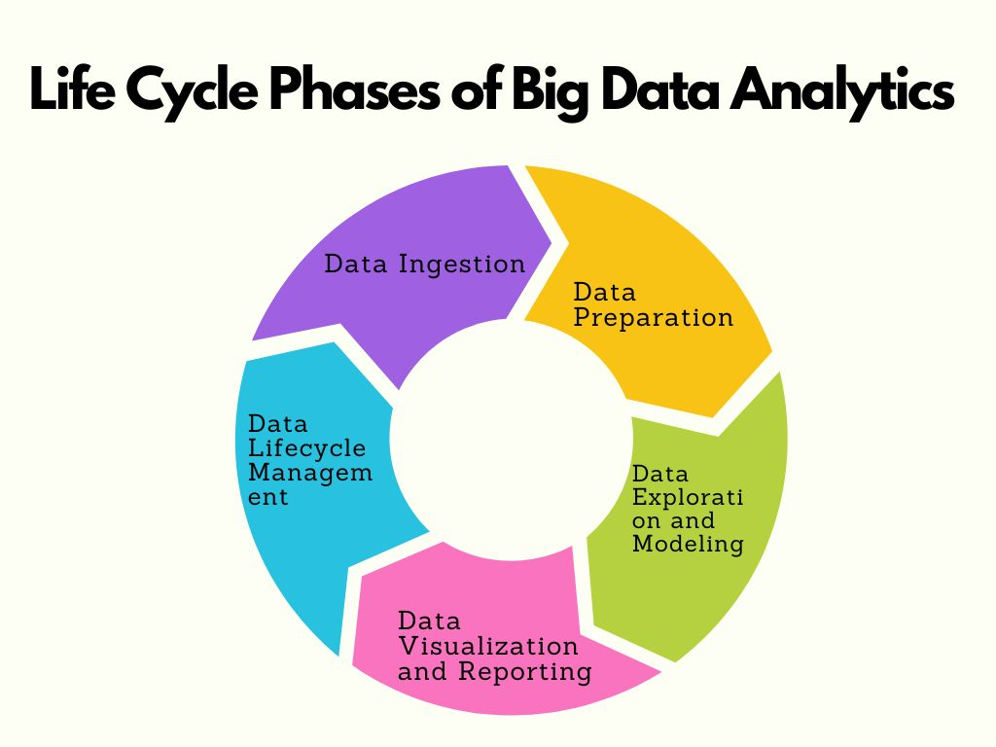

**The analytics flow of Big Data generally consists of several stages:**

1. **Data Ingestion:**

- The process begins with data ingestion, where data from various sources is collected and loaded into a Big Data platform. This may involve batch processing or real-time streaming of data.

2. **Data Storage:**

- Data is stored in distributed storage systems, often in a data lake or a distributed file system like Hadoop HDFS. Data is usually stored in its raw, unprocessed form.

3. **Data Processing:**

- Data is processed using distributed data processing frameworks like Apache Spark, Hadoop MapReduce, or Apache Flink.

4. **Data Transformation:**

- Data is often transformed into a structured format suitable for analysis. This may involve cleaning and formatting the data, converting it into a suitable schema, and handling missing or erroneous data.

5. **Analysis and Modeling:**

- Advanced analytics techniques, such as machine learning and statistical analysis, are applied to the transformed data to extract meaningful insights. This stage involves building models, training them, and running analyses.

6. **Data Visualization:**

- The results of the analysis are often visualized using tools like Tableau, Power BI, or custom dashboards. Data visualization helps stakeholders interpret and understand the insights.

7. **Reporting and Decision-Making:**

- The insights and findings from the analysis are presented in reports, dashboards, and presentations. These insights inform decision-making processes.

8. **Action and Optimization:**

- Based on the analysis, organizations take actions, make decisions, and optimize processes. This may involve adjusting strategies, changing business operations, or implementing recommendations.